**Hypothesis Testing Assignment**

1. A F&B manager wants to determine whether there is any significant difference in the diameter of the cutlet between two units. A randomly selected sample of cutlets was collected from both units and measured? Analyze the data and draw inferences at 5% significance level. Please state the assumptions and tests that you carried out to check validity of the assumptions.

**Answer:-**

**Step1: Business Problem:** Two check whether the diameter of two units are similar or not?

**Step2: y and x:** So here is y is continuous and x is discrete

**Step3: Here we will use 2-sample t test**

**Step4: Find normality of this data**

> Cutlets <- read.csv("C:/PRATIK/Data Science/Assignment/Hypothesis Testing/Cutlets.csv")

> View (Cutlets)

> attach (Cutlets)

> Boxplot (Cutlets)

> # H0 = There is no significant difference in the diameter of the cutlets bet 2 units

> # Ha = There is a difference in the diameter of the cutlets bet 2 units

> # Here we will use 2 sample t test and

> # if p-value is > 0.05 => Accept the Null Hypothesis

> # if p-value is < 0.05 => Reject Null Hypothesis

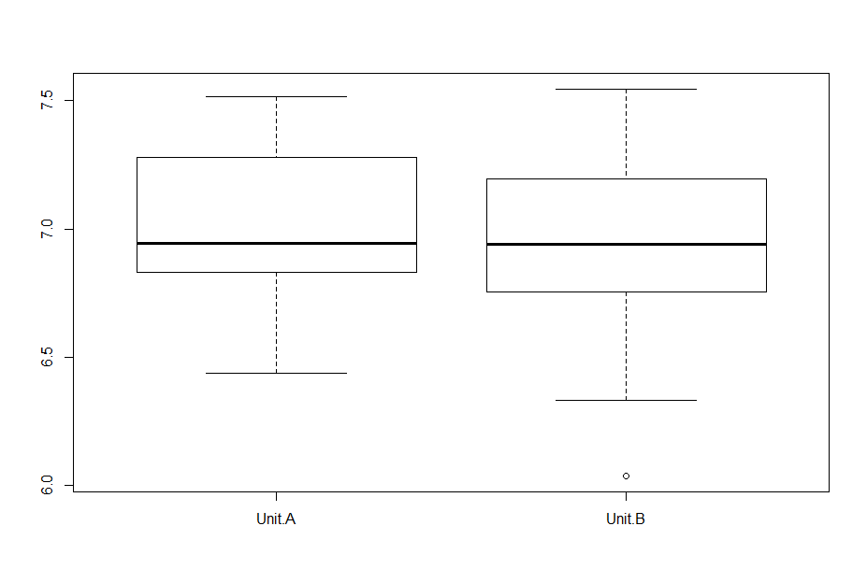

> library("dplyr")

> library("ggpubr")

> data <- read.csv(file.choose())

> set.seed(1234)

> dplyr::sample_n(data, 10)

Unit.A Unit.B

1 6.6801 6.9182

2 6.8394 7.0240

3 7.1560 7.4220

4 7.4488 7.1522

5 7.5169 7.4059

6 6.5797 7.1581

7 6.6840 7.2402

8 7.2783 7.1180

9 7.3871 6.8110

10 7.3943 6.5780

> library(ggpubr)

> ggqqplot(data$Unit.A)

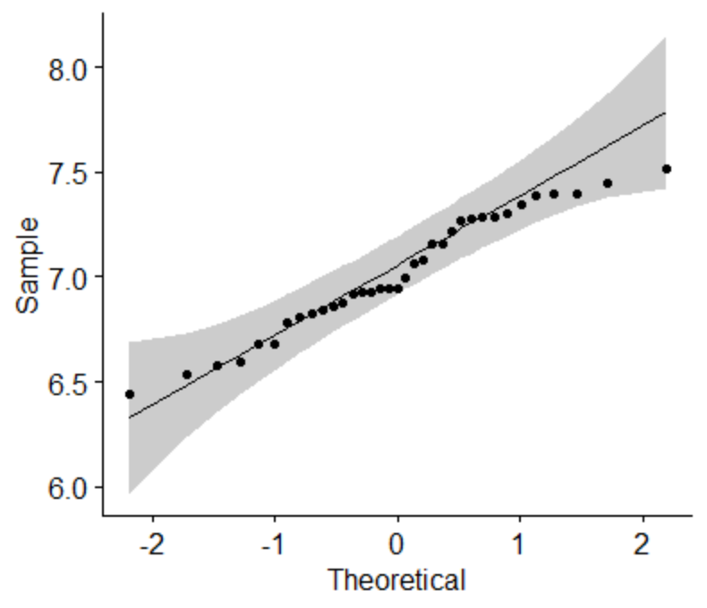

> ggqqplot(data$Unit.B)

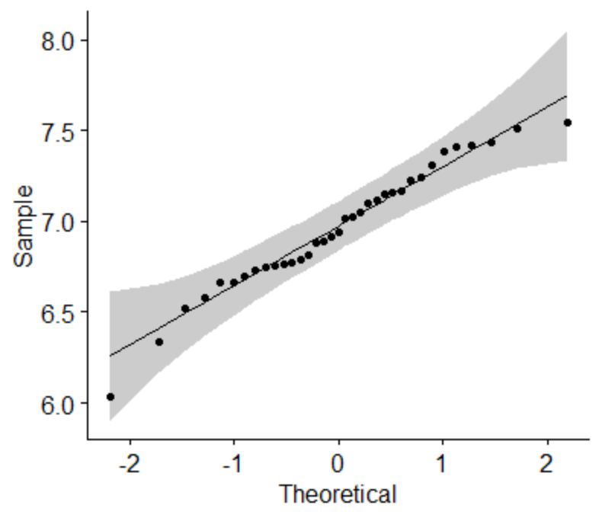

t.test(Unit.A, Unit.B, alternative = "two.sided", var.equal = FALSE)

Welch Two Sample t-test

data: Unit.A and Unit.B

t = 0.72287, df = 66.029, p-value = 0.4723

alternative hypothesis: true difference in means is not equal to 0

95 percent confidence interval:

-0.09654633 0.20613490

sample estimates:

mean of x mean of y

7.019091 6.964297

Here our p-value is > 0.05, so data are normal

H0: variance of Unit.A = variance of Unit.B

Ha: variance of Unit.A NOT= variance of Unit.B

We can go for further test which is **variance test**

> var(data$Unit.A)

[1] 0.08317945

> var(data$Unit.B)

[1] 0.117924

> chisq.test(data)

Pearson's Chi-squared test

data: data

X-squared = 0.45428, df = 34, p-value = 1

As per chi-square test p-value is 1.00 > 0.05 = Accept Ho

H0: variance of Unit.A = variance of Unit.B

**2 Sample t test for compare mean**

H0: Average of Unit.A = Average of Unit.B

Ha: variance of Unit.A NOT = variance of Unit.B

> t.test(data$Unit.A,data$Unit.B)

Welch Two Sample t-test

data: data$Unit.A and data$Unit.B

t = 0.72287, df = 66.029, p-value = 0.4723

alternative hypothesis: true difference in means is not equal to 0

95 percent confidence interval:

-0.09654633 0.20613490

sample estimates:

mean of x mean of y

7.019091 6.964297

P-value is 0.4723 > 0.05=> Accept Ho, hence Average of unit A = Average of unit B

There is no significant difference in the diameter of the cutlets bet 2 units

**2.** A hospital wants to determine whether there is any difference in the average Turnaround Time (TAT) of reports of the laboratories on their preferred list. They collected a random sample and recorded TAT for reports of 4 laboratories. TAT is defined as sample collected to report dispatch.

Analyze the data and determine whether there is any difference in average TAT among the different laboratories at 5% significance level.

**Answer:**

Business Problem: TAT for all 4 laboratories are same or different

H0: Data are normal

Ha: Data are not normal

H0: There is no difference in average TAT among those laboratories

Ha: There is a difference in average TAT among those laboratories

P-value <=5% then accept the Ha/Reject H0 (There is difference in average TAT)

P-value >5% then accept the H0/Fail to reject H0 (There is no difference in average TAT)

**Normality Test:**

**Lab 1:**

> shapiro.test(my_data$Laboratory.1)

Shapiro-Wilk normality test

data: my_data$Laboratory.1

W = 0.99018, p-value = 0.5508

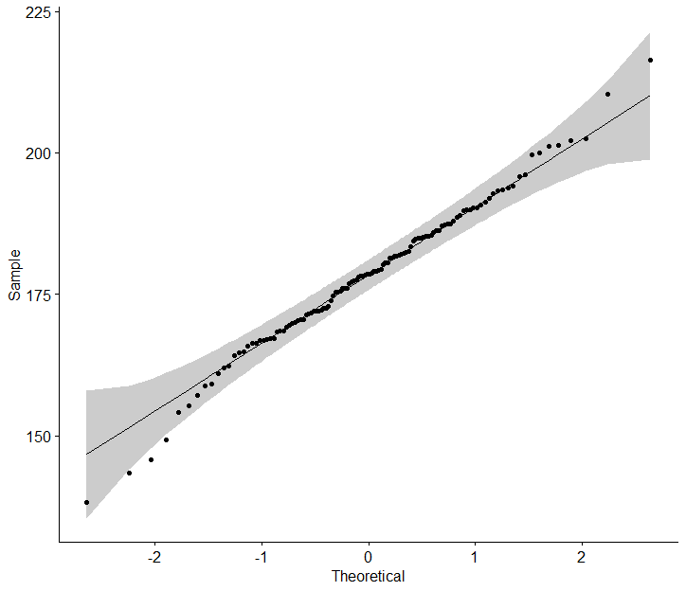

P-value = 0.5508 > 0.05 => Accept H0

|  |
| --- |
|  |
|  |
| |  | | --- | |  | |

**Lab 2:**

> shapiro.test(my_data$Laboratory.2)

Shapiro-Wilk normality test

data: my_data$Laboratory.2

W = 0.99363, p-value = 0.8637

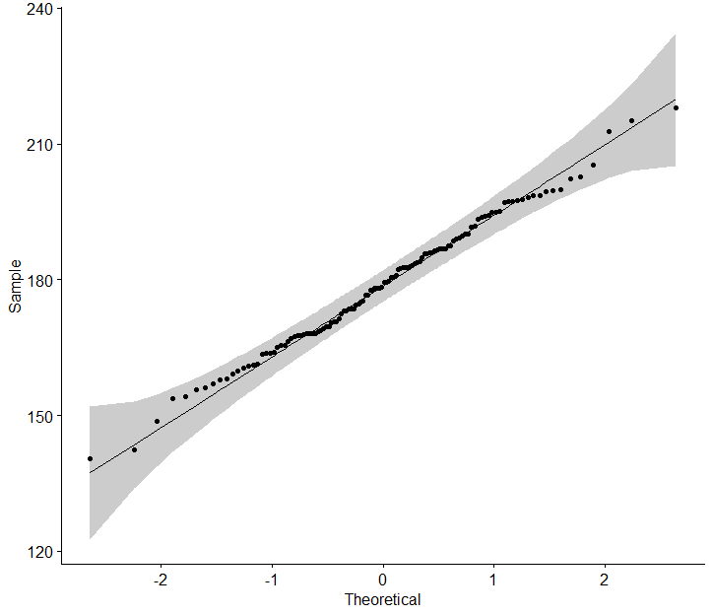

|  |
| --- |
| P-value = 0.8637 > 0.05 => Accept H0 |
|  |
| |  | | --- | |  | |

**Lab 3:**

> shapiro.test(my_data$Laboratory.3)

Shapiro-Wilk normality test

data: my_data$Laboratory.3

W = 0.98863, p-value = 0.4205

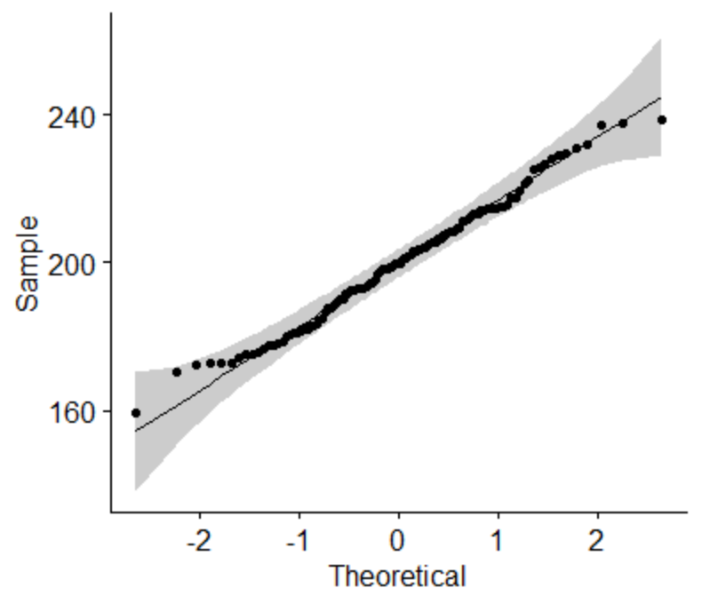

P-value = 0.4205 > 0.05 => Accept H0

|  |
| --- |
|  |
|  |
| |  | | --- | |  | |

**Lab 4:**

> shapiro.test(my_data$Laboratory.4)

Shapiro-Wilk normality test

data: my_data$Laboratory.4

W = 0.99138, p-value = 0.6619

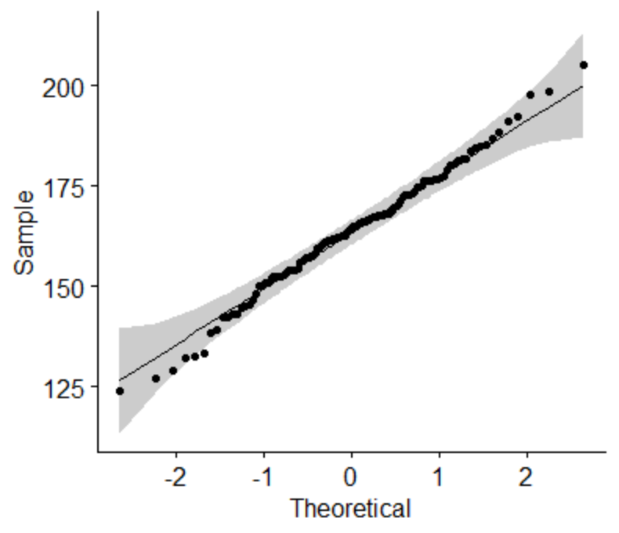

|  |
| --- |
| P-value = 0.6619 > 0.05 => Accept H0 |
|  |
| |  | | --- | |  | |

> boxplot(my_data)

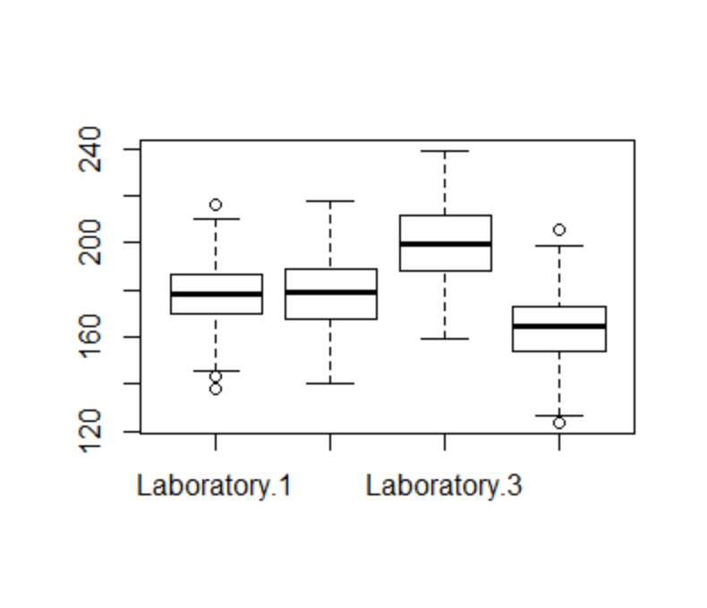

Here data are normal so we will do the **Variance Test:**

H0 = σ2 (L1)= σ2 (L2)= σ2 (L3)………………… (All variances are equal)

Ha = σ2 (L1)≠ σ2 (L2)≠ σ2 (L3)………………... (At least 1 variance is different)

H0 = Variance TAT of all 4 Labs are same

Ha = Variance TAT of at least 1 Lab is different

By using F-Test

> res.ftest <- var.test(lab$Laboratory.1,lab$Laboratory.2,data = lab)

> res.ftest

F test to compare two variances

data: lab$Laboratory.1 and lab$Laboratory.2

F = 0.77573, num df = 119, denom df = 119, p-value = 0.1675

alternative hypothesis: true ratio of variances is not equal to 1

95 percent confidence interval:

0.5406345 1.1130690

sample estimates:

ratio of variances

0.7757342

> res.ftest <- var.test(lab$Laboratory.2,lab$Laboratory.3,data = lab)

> res.ftest

F test to compare two variances

data: lab$Laboratory.2 and lab$Laboratory.3

F = 0.81785, num df = 119, denom df = 119, p-value = 0.2742

alternative hypothesis: true ratio of variances is not equal to 1

95 percent confidence interval:

0.5699887 1.1735038

sample estimates:

ratio of variances

0.8178532

> res.ftest <- var.test(lab$Laboratory.3,lab$Laboratory.4,data = lab)

> res.ftest

F test to compare two variances

data: lab$Laboratory.3 and lab$Laboratory.4

F = 1.2021, num df = 119, denom df = 119, p-value = 0.3168

alternative hypothesis: true ratio of variances is not equal to 1

95 percent confidence interval:

0.8377527 1.7247817

sample estimates:

ratio of variances

1.202057

Here p-value is > 0.05 => Accept Ho, hence we prove variance of all laboratory are same

**3.** Sales of products in four different regions is tabulated for males and females. Find if male-female buyer rations are similar across regions.

**Answer:**

**Step 1:** **Business Problem**: Male-female buyer rations are similar across regions

**Step 2: y and x :** x is more than 2 discrete and y is discrete

**Step 3: Here we will use Chi-square test**

H0: Data are normal

Ha: Data are not normal

H0: Male-female buyer rations are similar across regions

Ha: Male-female buyer rations are not similar across regions

P-value <=5% then accept the Ha/Reject H0 (male-female buyer rations are similar)

P-value >5% then accept the H0/Fail to reject H0 (male-female buyer rations are not similar)

**Normality Test**:

East Region:

>hist(my_data1$East)

|  |
| --- |
|  |
|  |
| |  | | --- | |  | |

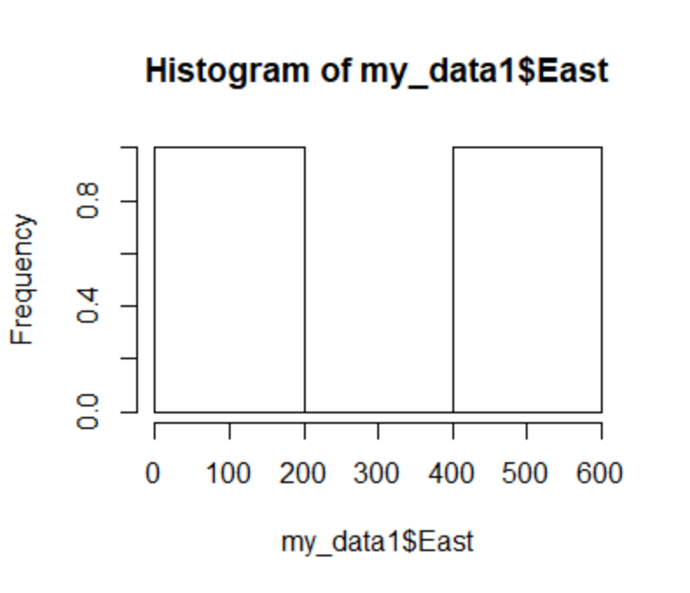

> ggqqplot(my_data1$East)

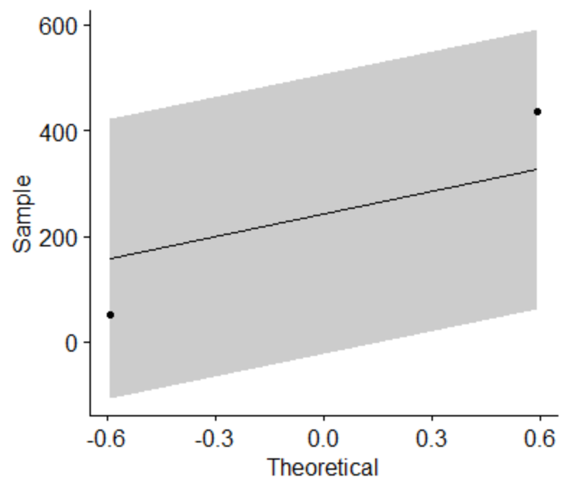

> t.test(my_data1$East, alternative = "two.sided", var.equal = FALSE)

One Sample t-test

data: my_data1$East

t = 1.2597, df = 1, p-value = 0.4271

alternative hypothesis: true mean is not equal to 0

95 percent confidence interval:

-2203.444 2688.444

sample estimates:

mean of x

242.5

West Region:

> hist(my_data1$West)

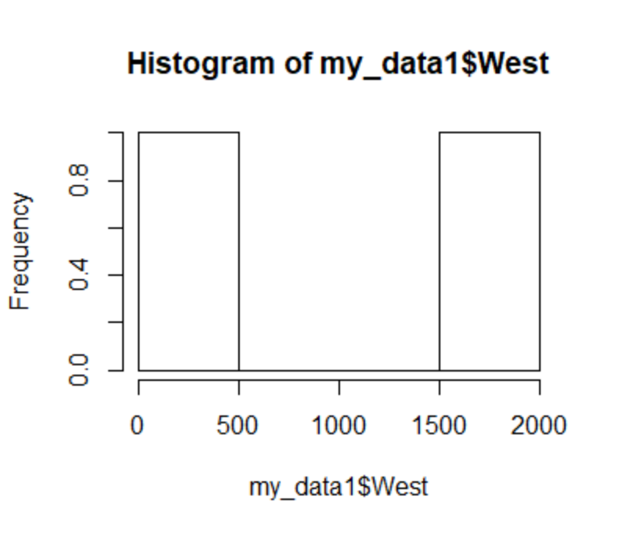

> ggqqplot(my_data1$West)

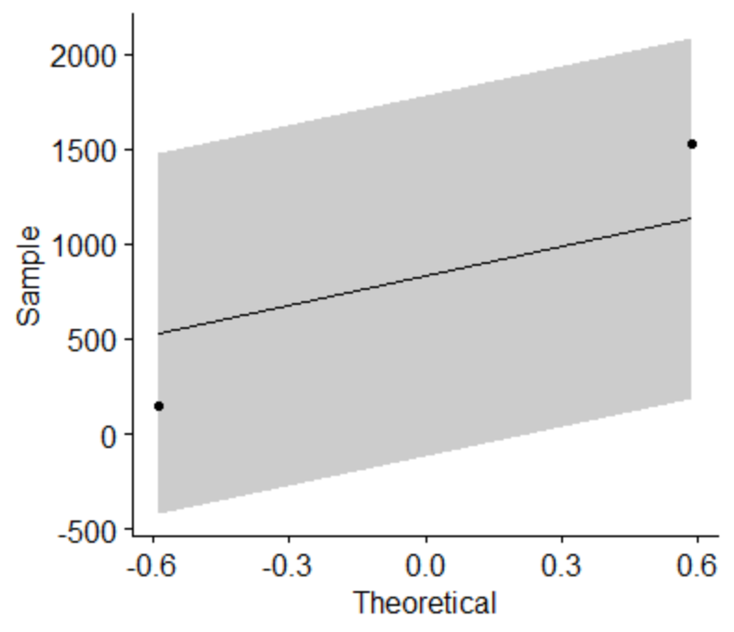

> t.test(my_data1$West, alternative = "two.sided", var.equal = FALSE)

One Sample t-test

data: my_data1$West

t = 1.2056, df = 1, p-value = 0.4408

alternative hypothesis: true mean is not equal to 0

95 percent confidence interval:

-7941.134 9606.134

sample estimates:

mean of x

832.5

North Region:

> hist(my_data1$North)

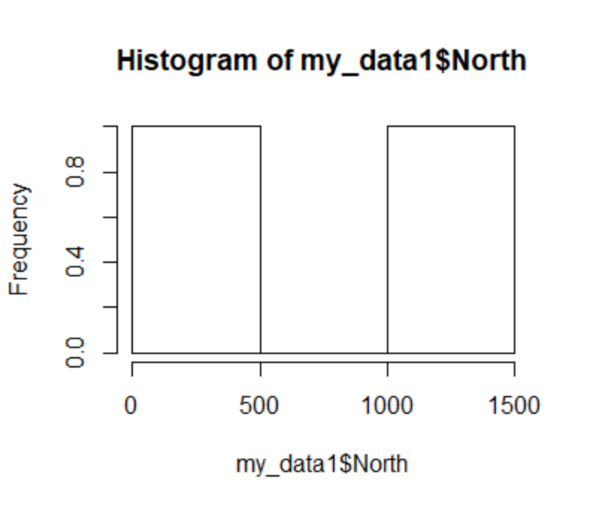

> ggqqplot(my_data1$West



> t.test(my_data1$North, alternative = "two.sided", var.equal = FALSE)

One Sample t-test

data: my_data1$North

t = 1.2139, df = 1, p-value = 0.4387

alternative hypothesis: true mean is not equal to 0

95 percent confidence interval:

-7039.05 8526.05

sample estimates:

mean of x

743.5

South Region:

> hist(my_data1$South)

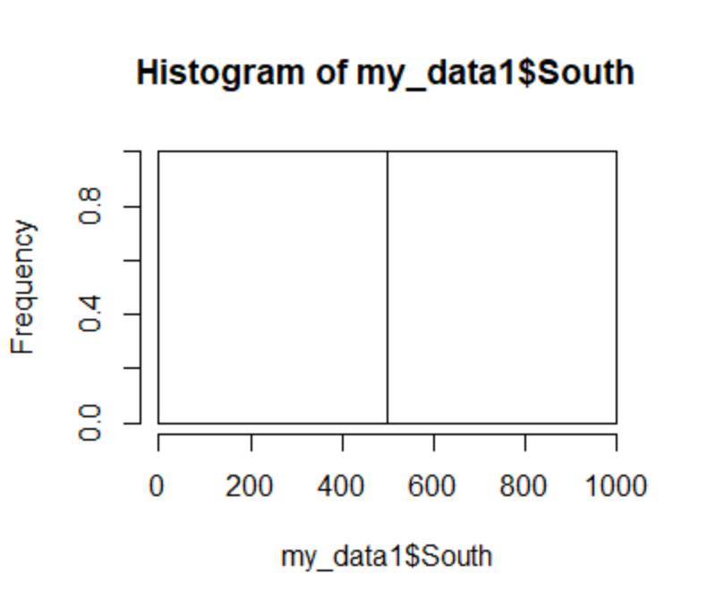

> ggqqplot(my_data1$South)

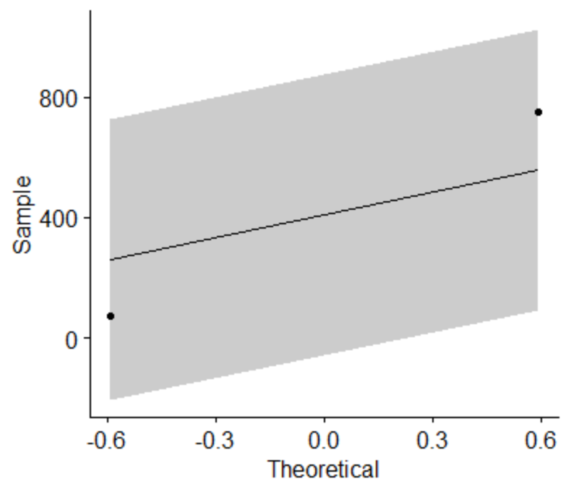

> t.test(my_data1$South, alternative = "two.sided", var.equal = FALSE)

One Sample t-test

data: my_data1$South

t = 1.2059, df = 1, p-value = 0.4408

alternative hypothesis: true mean is not equal to 0

95 percent confidence interval:

-3910.11 4730.11

sample estimates:

mean of x

410

For all regions the P value is greater than 0.05 Hence we accept the H0.

**4**. **Tele Call uses 4 centers around the globe to process customer order forms. They audit a certain % of the customer order forms. Any error in order form renders it defective and has to be reworked before processing. The manager wants to check whether the defective % varies by center. Please analyze the data at *5%* significance level and help the manager draw appropriate inferences**

**Answer:**

**Step1: Business Problem:** To check whether the defective % varies by center or not

**Step2**: **y and x**

x is more than 2 discrete and y is discrete

**Step3**: **Here we will use Chi-square test**

H0: All are same

Ha: at least 1 are different

> chisq.test(telecall$Phillippines, telecall$Indonesia, correct=FALSE)

Pearson's Chi-squared test

data: telecall$Phillippines and telecall$Indonesia

X-squared = 0.55216, df = 1, p-value = 0.4574

> chisq.test(telecall$Malta, telecall$India, correct=FALSE)

Pearson's Chi-squared test

data: telecall$Malta and telecall$India

X-squared = 2.4695, df = 1, p-value = 0.1161

> chisq.test(telecall$Malta, telecall$Phillippines, correct=FALSE)

Pearson's Chi-squared test

data: telecall$Malta and telecall$Phillippines

X-squared = 0.41474, df = 1, p-value = 0.5196

P-value is 0.5196 > 0.05=> Accept Ho, hence Average are same

As per results we can say that all the canters are equal.

**5**. Fantaloons Sales managers commented that *%* of males versus females walking in to the store differ based on day of the week. Analyze the data and determine whether there is evidence at *5 %* significance level to support this hypothesis.

**Answer:**

**Step1: Business Problem:** To find proportion male vs female differ from weekdays or weekends are equal or not

**Step2: y and x**

x is discrete with 2 categories and y is discrete

**Step3: Here we will use 2-Proportion test**

**2-Proprotion Test**

H0: Proportion of male vs female in weekdays = Proportion of male vs female in weekends

Ha: Proportion of male vs female in weekdays NOT = Proportion of male vs female in weekends

> faltoons <- read.csv(file.choose())

> chisq.test(faltoons$Weekdays, faltoons$Weekend, correct=FALSE)

Pearson's Chi-squared test

data: faltoons$Weekdays and faltoons$Weekend

X-squared = 0.0015979, df = 1, p-value = 0.9681

P-value is 0.968 > 0.05 => Accept Ho

Hence Proportion of male vs female in weekdays = Proportion of male vs female in weekends